PROVINCE OF KWAZULU-NATAL

# DEPARTMENT OF EDUCATION



# PINETOWN DISTRICT

# SENIOR CETRIFICATE

# GRADE 11

`

# INFORMATION TECHNOLOGY P1

# 

# FINAL EXAMINATIONS 2016

**Marks: 150**

**Time: 3 hours**

**This question paper consists of 11 pages excluding this cover page.**

|  |  |  |
| --- | --- | --- |
| **INSTRUCTIONS AND INFORMATION** | | |
|  |  |  |
| 1. | This question paper contains **THREE** questions. |  |
|  |  |  |
| 2. | Answer **ALL** the questions. |  |
|  |  |  |
| 3. | The duration of this examination is **three hours**. Because of the nature of this examination it is important to note that you will not be permitted to leave the examination room before the end of the examination session. |  |
|  |  |  |
| 4. | This question paper is set in programming terms that are specific to the **Delphi programming** language. |  |
|  |  |  |
| 5. | Make sure that you answer the questions according to the specifications that are given in each question. Marks will only be awarded based on the set requirements. |  |
|  |  |  |
| 6. | Only answer what is asked in each question. For example, if the question does not ask for data validation, then no marks will be awarded for data validation. |  |
|  |  |  |
| 7. | Your programs must be coded in such a way that they will work with any data and not just the sample data supplied or any data extracts that appear in the question paper. |  |
|  |  |  |
| 8. | Make sure that you develop routines, such as search, sort and selection, from first principles and not use the built-in features of a programming language for any of these routines. |  |
|  |  |  |
| 9. | You, as the programmer, must define all data structures. You may not use components provided within the user interface to store and later retrieve data. |  |
|  |  |  |
| 10. | **Save your work regularly** on the disk (CD/flash disk/DVD, et cetera) that you have been given, or on the disk space allocated to you for this examination. |  |
|  |  |  |
| 11. | Make sure that your name appears as a comment in the first line of code you did to answer a question. Also include the question number as part of the comment. |  |
|  |  |  |
| 12. | If printouts are required make printouts of the code of all the programs/classes/units that you did and NOT of the code that is generated automatically. |  |
|  |  |  |
| 13. | Printing must be done after the examination within the timeframe provided for printing. |  |
|  |  |  |
| 14. | At the end of this examination session, you must hand in the disk/CD with all your work saved on it OR you must make sure that all your work has been saved on the disk space allocated to you. Ensure that all files can be read. |  |
|  |  |  |
| 15. | You have been supplied with either a disk or disk space containing files you need to complete this question paper. |  |
|  |  |  |
| 16. | Follow the instructions provided for each question to complete the question paper. |  |

|  |
| --- |
| **SCENARIO**  The owner of a newly opened computer sales store has appointed you to use your software development skills to help them with administrative tasks. Your main job is to design software to do the following:   * Calculate instalments for credit customers * Work out interest rates * Capture sales details and producing stats on salesmen and items sold. * Control stock * Manage suppliers   The following data files have been provided in a folder called **Nov2016P1Gr11Data**. All the necessary files are found in subfolders Q1, Q2 and Q3. Kindly ensure that you have these files. |

**QUESTION ONE**

***Clients are always accusing the salesman of adding hidden costs hence inflating the value of the item.***

* 1. The owner has requested that you write simple code to help the sales team with the calculation of Hire Purchase details. The HP agreement allows the client to pay a deposit and pay the balance over a period of time in monthly instalments. A fixed interest rate of 18.5% per annum is charged.

Write code for the button **FIND DEPOSIT**.

* Name, Net salary and Item price must be obtained from the given edit boxes.
* The required deposit is worked out according to the given table using the net salary earned.
* Display a single string in a label which is dynamically instantiated when the button is clicked as shown in the Sample output. (12)

|  |  |
| --- | --- |
| **Net Salary** | **Deposit** |
| Below R5000 | 25% |
| >=R5000 < R8000 | 15% |
| >=R8000 < R15000 | 10% |
| >=R15000 < R20000 | 5% |
| >=R20000 | No Deposit |

**Sample Output**

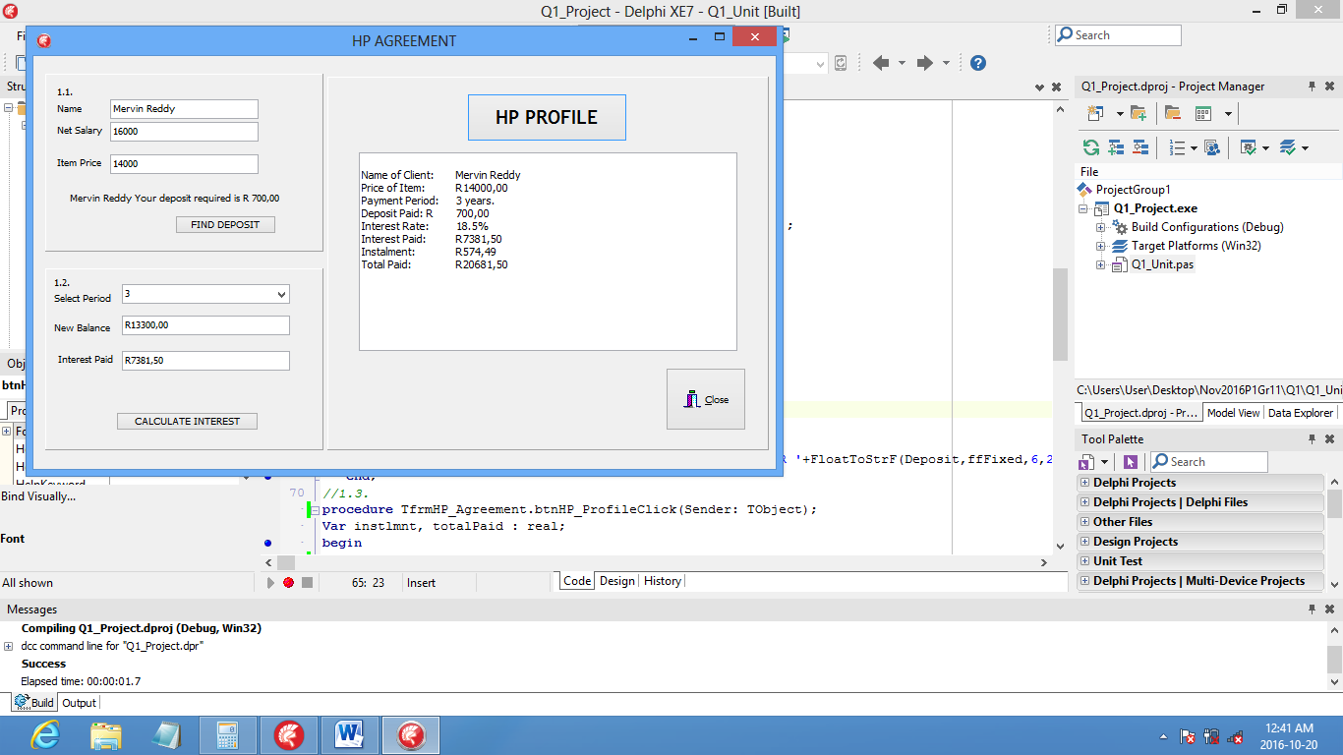

* 1. When the **CALCULATE INTEREST** button is clicked, the following should occur:

* + 1. The period (in years) is to be selected from the combo box and sent to an identifier  
       called **per**. (2)
    2. The new balance owing must be calculated and displayed in the relevant block.  
       New Balance = **Item Price – deposit**  (3)
    3. The interest must be calculated using the formula: **SI = p.i.n** where:

**p** = Principal amount, **i** = interest rate, **n** = number of years (2)

Display the interest amount in the appropriate space provided. (2)

**\*NB You must run 1.1 before 1.2**

**Sample Output:**



* 1. Write code for the **HP PROFILE** button to do the following when clicked:
     1. Calculate the monthly Instalment over the time period selected by the user. (3)
     2. Calculate the total amount of money the client would have spent at the end of the   
        payment period. (2)
     3. Display the entire profile using all the inputs already given by the client, as shown below: (3)

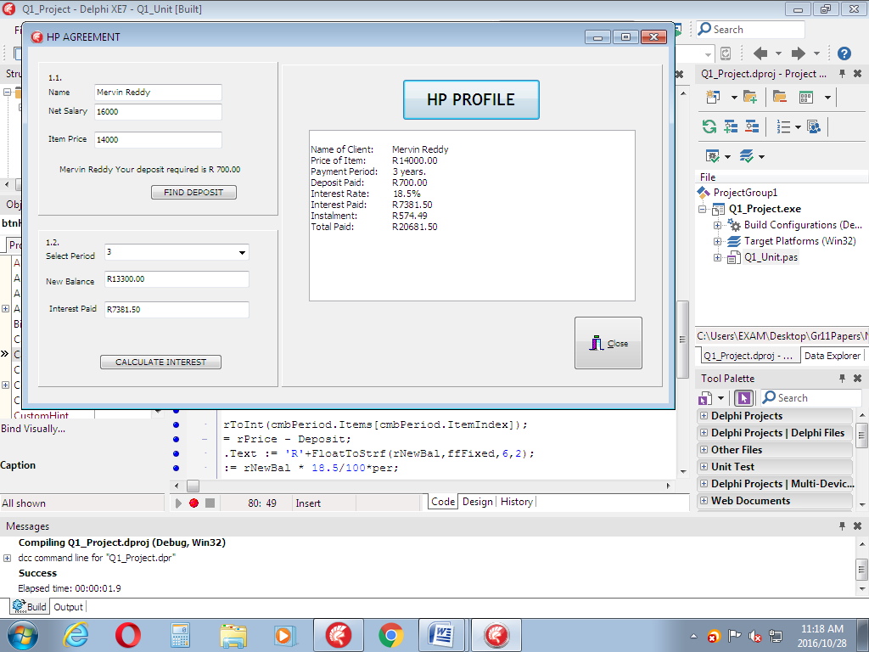**Sample Output:**

**[29]**

**QUESTION TWO**

At the end of every month, the sales team compiles a sales report, in the form of a text file with the following format:

**SaleID,Brand,Processor type,Salesman’s name,Price**

|  |  |
| --- | --- |
| SalesID | A combination of 8 alphanumeric characters |
| Brand | Name of the brand of the product sold |
| Processor type | The processor model e.g. i3, i5, i7 or celeron |
| Name of Salesman | Initial and Surname of the salesman e,g. P.Reddy |
| Price | Price of the product sold |

Below is a sample of the data in the text file called **SalesData.txt**.

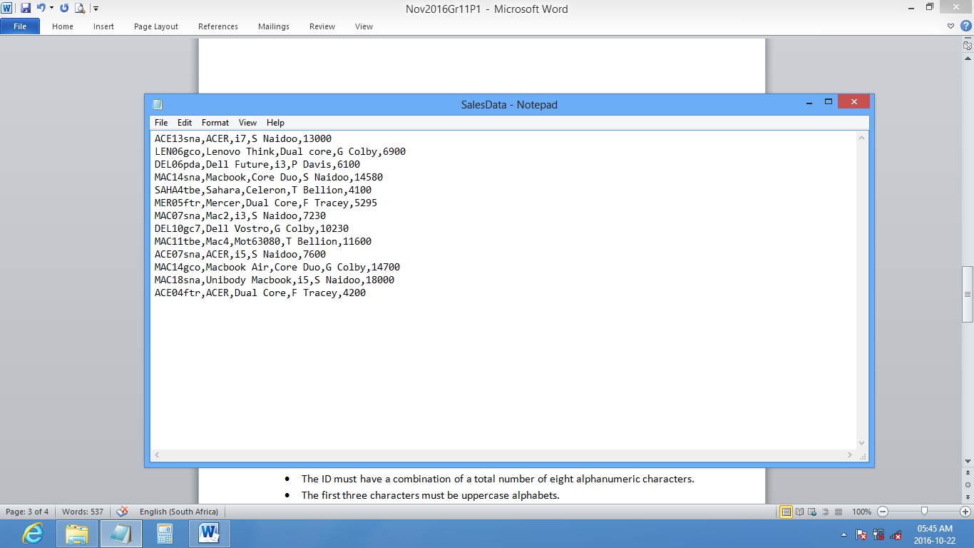

Open the Delphi project found in the **Q2** folder. Complete the code according to the questions asked.

2.1. Declare an array called **arrFilDat**, with class scope, to store up to 25 strings at a time.  
 Also declare a suitable counter variable to store the number of valid Sales ID’s generated. (3)

2.2. Write a method called **ValidateSaleID** that will accept a string containing the Sales ID and

tests for the validity of the ID. The method must return **True** if the ID is valid. The validity

check is given below:

* The ID must have a combination of a total number of eight alphanumeric characters.
* The first three characters must be uppercase alphabets.
* This is followed by two randomly generated digits.
* The last three characters must be 3 lowercase characters. (11)

2.3. Write code for the **Read File Validate ID** button that will read data from the text

file **SalesData.txt** by doing the following:

* Check if the text file exists. If it does not exist, then return a suitable message. If it does exist, then read the data, line by line from the text file using an appropriate looping structure and store it in the array created.
* Call the method to check if the ID is valid.
* Display all valid ID’s, the number of valid and invalid ID’s as shown in the sample output below:

(14)

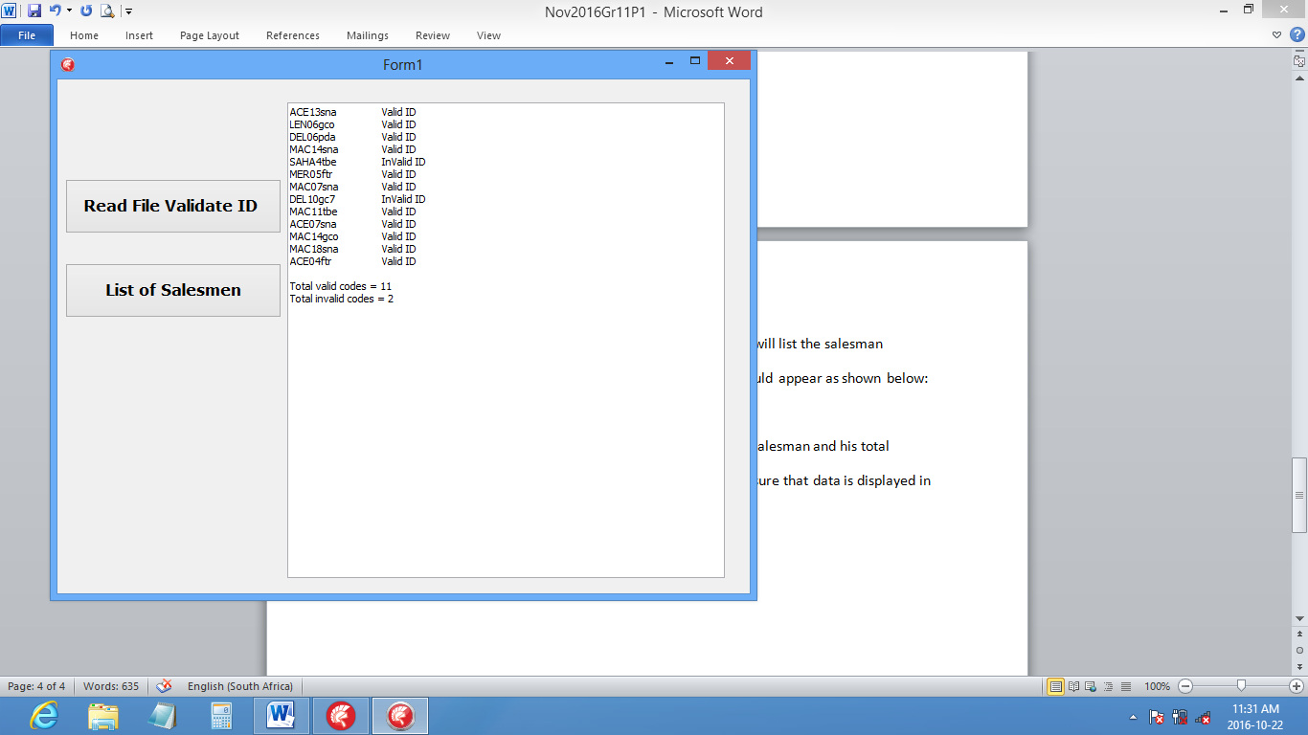**Sample output**

2.4. Write the code for the **List of Salesman** button that will list all the different

salesmen for the month. You must store this list in an array. Display the number of

salesmen for the month. (14)

**Sample Output:**

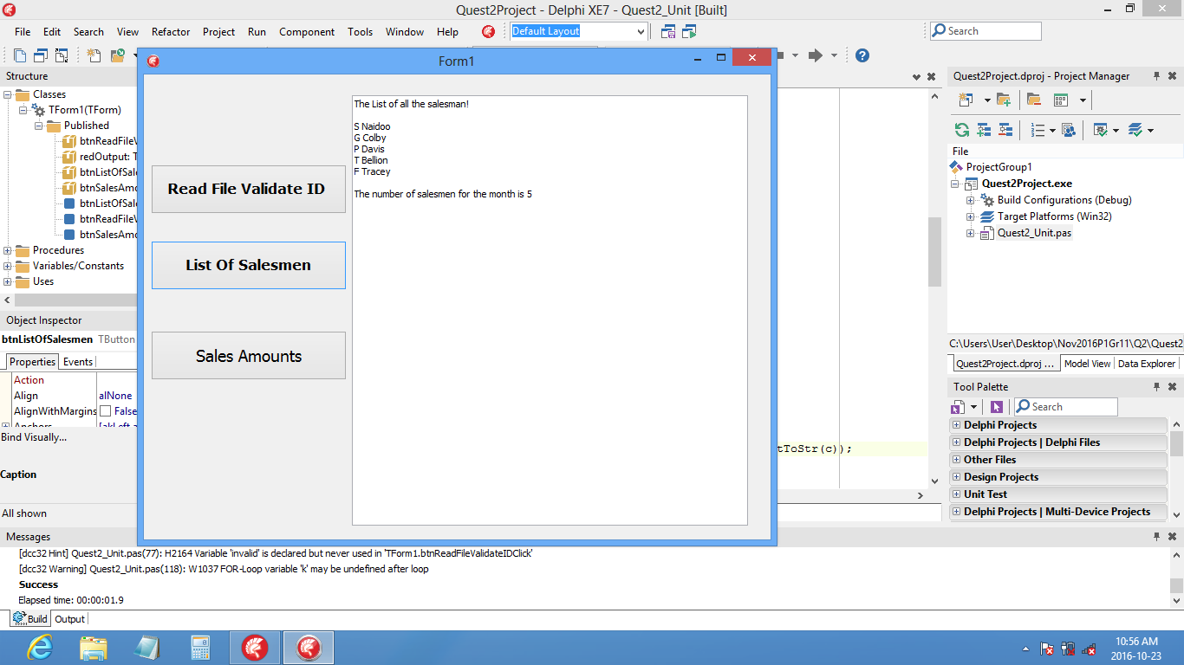

2.5. Write the code for the button **Sales Amounts** that will display each salesman and

his total sales for the month. (8)

**Sample Output:**

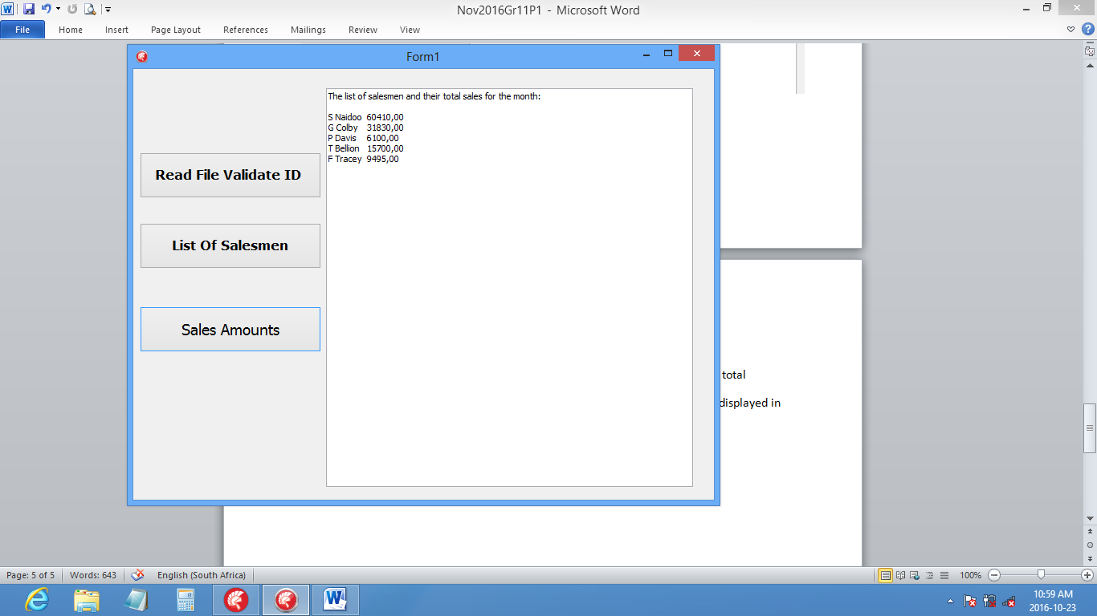

2.6. Code the button **Sales Order** to display the name of the salesman and his total

Sales in columns with suitable headings. Your code must ensure that data is displayed in

descending order of sales amount of each salesman. Use a Selection or Bubble

sorting technique (8)

**Sample Output:**

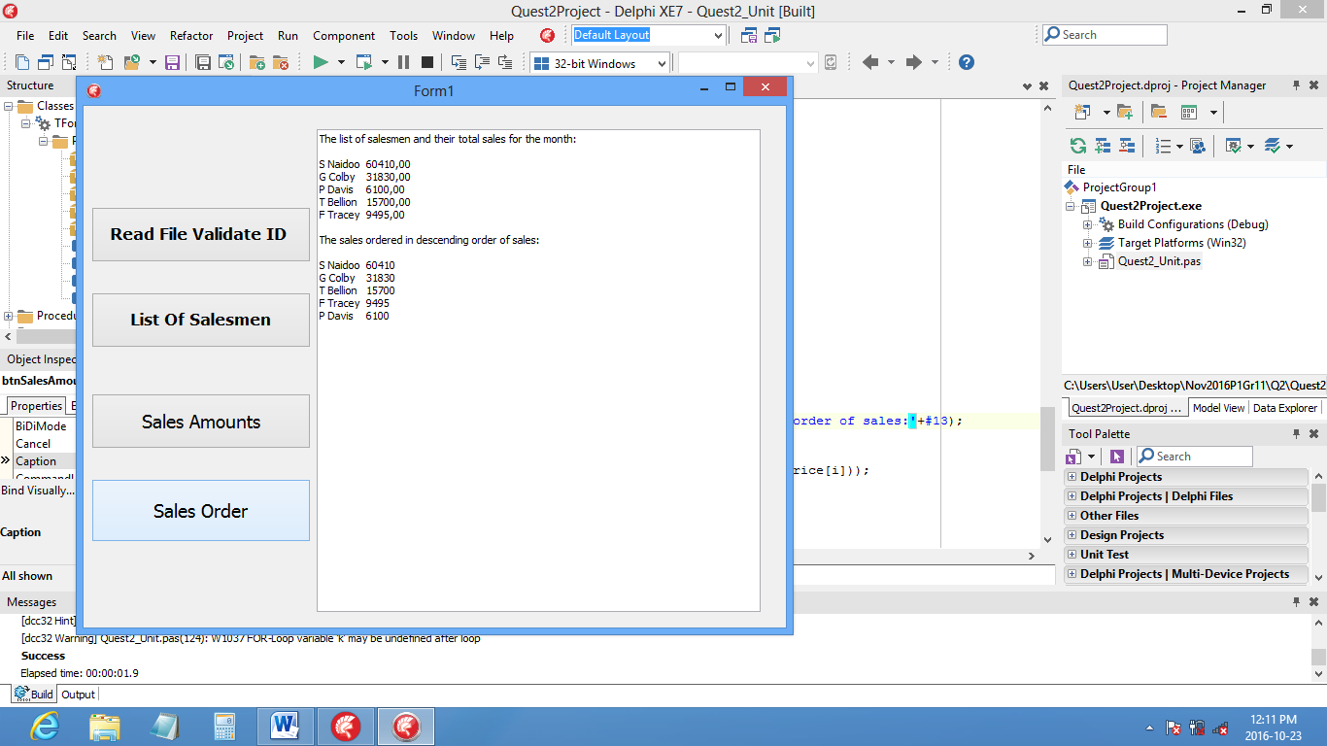

2.7. The salesmen on the current list are only those who have made sales for this month. If a

salesman does not make any sales then he is not listed. Some months, there are many

salesmen that make the list. Therefore it becomes very difficult to carry out a manual search

for a certain salesman in the current list. Write code for the **Search for Salesman** button to

allow the user to check if the salesman made the list. Write a procedure called

***SalesmanSearch***to carry out the search and display a suitable message in a message dialog

box. The user must be prompted for a search name. (11)

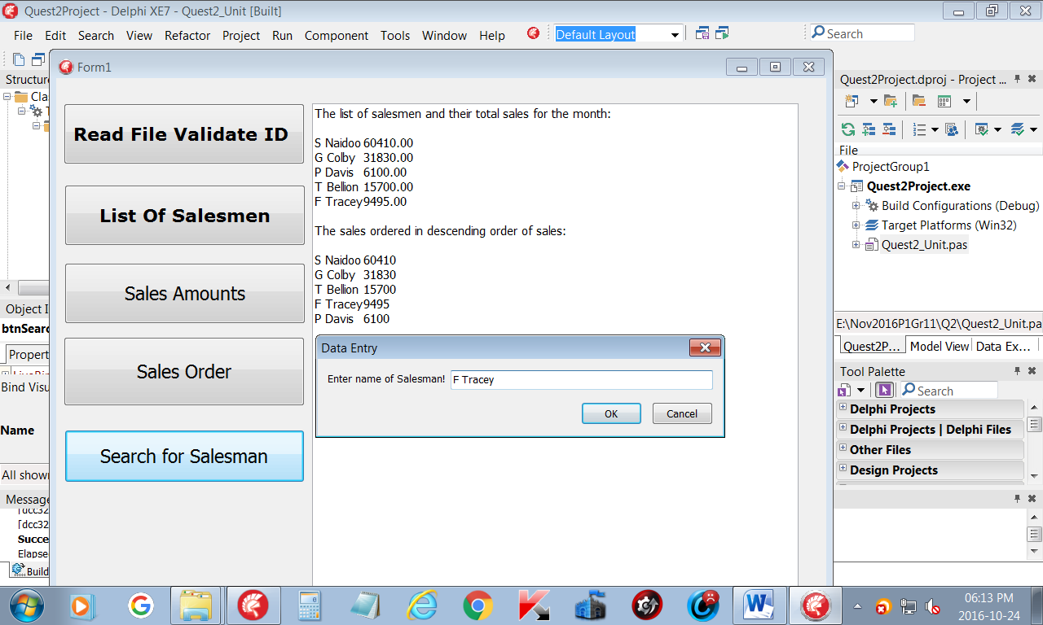

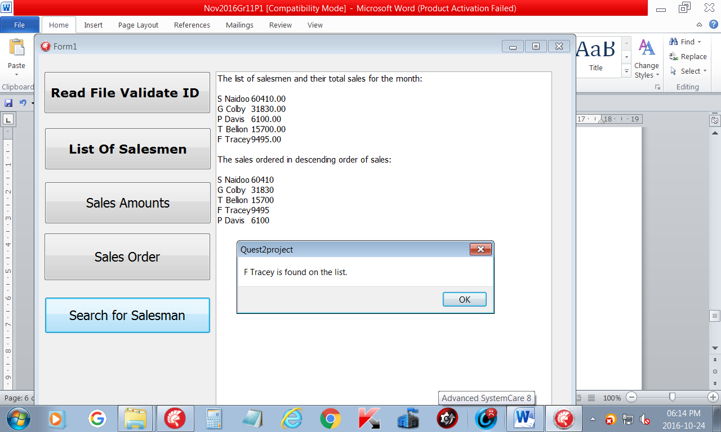 **[69]**

**QUESTION THREE**

The sales manager is trying to manage his sales team with the limited knowledge he has of database tables in Access.

You are required to write code to help him manage the table by writing code to manipulate the data. The details of the database is given as follows:

Name of database : **SalesTeam**

Location of database: Inside the folder called **Q3**.

Name of the table: **tblTeam**

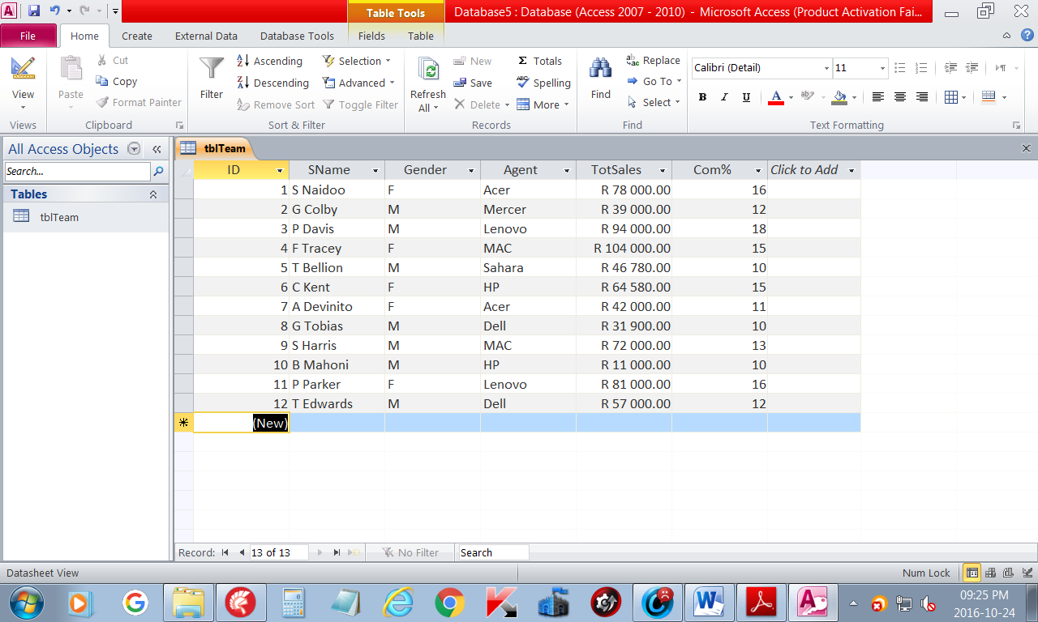

The program should be able to connect to the database named medals.mdb. If you find that the connectivity is not in place, use the following steps to establish connection with the database:

* Click on the TADOTable component named adoCon.
* Click on the Ellipse button (three dots) to the right of the ‘ConnectionString’ property in the Object Inspector.
* Click on the Build button which takes you to the Data Link Properties dialogue box.
* The connection string is already defined. You may have to change the provider.

Select Microsoft Jet 4.0 OLE DB if the database extension is .mdb.

If the extension of your database is .accdb then select Microsoft.ACE.OLEDB.12.0.

* Click on Next.
* The first option on the Connection tabsheet allows you to browse and find the **SalesTeam.accdb** file.
* Remove the user name Admin.
* Click on the Test Connection button. Click OK on each one of the open dialogue windows.

**NB.** If you cannot establish connectivity with the database at all when you execute the program

you must still code and submit the programming code for marking.

The two tabs in the form Q3 represents two views requested by the administration department. The General View tab requires results from the table onto a grid while the Office View requests information on a simple text area.

**Write the necessary code for the buttons as described below in the General View section:**

3.1. Create a filter to display the data of female team members. Indicate in a ShowMessage how   
 many entries are recorded. Write the respective codes in the **FILTER BY FEMALES** button. (6)

**Sample Run:**

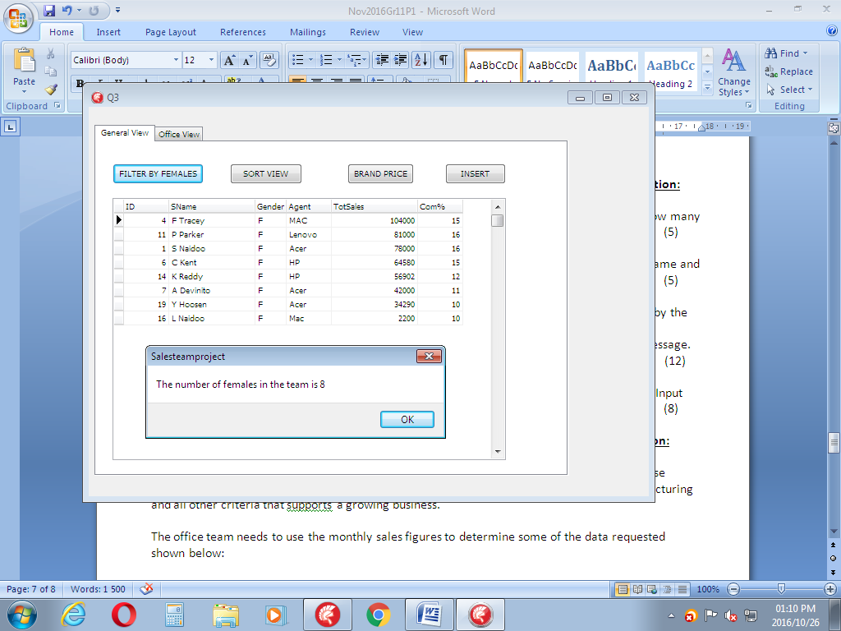

3.2. Write the code for the button **SORT VIEW** that displays the data sorted alphabetically by name   
 and then in descending order of total sales. (5)

**Sample Output:**

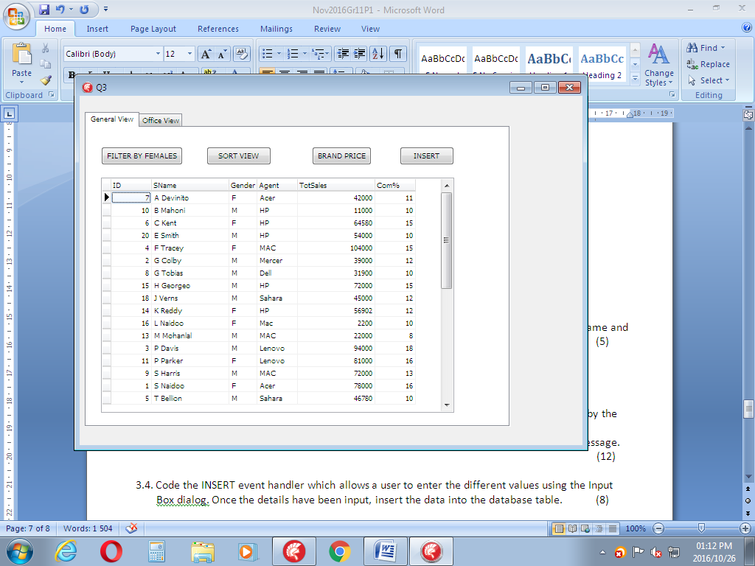

3.3. Write code for the **BRAND PRIC**E button to calculate the total Rand value of that particular  
 computer brand as entered by the user (use an inputbox component). If the brand entered is not  
 found, display a suitable message.

(12)

**Sample Output:**

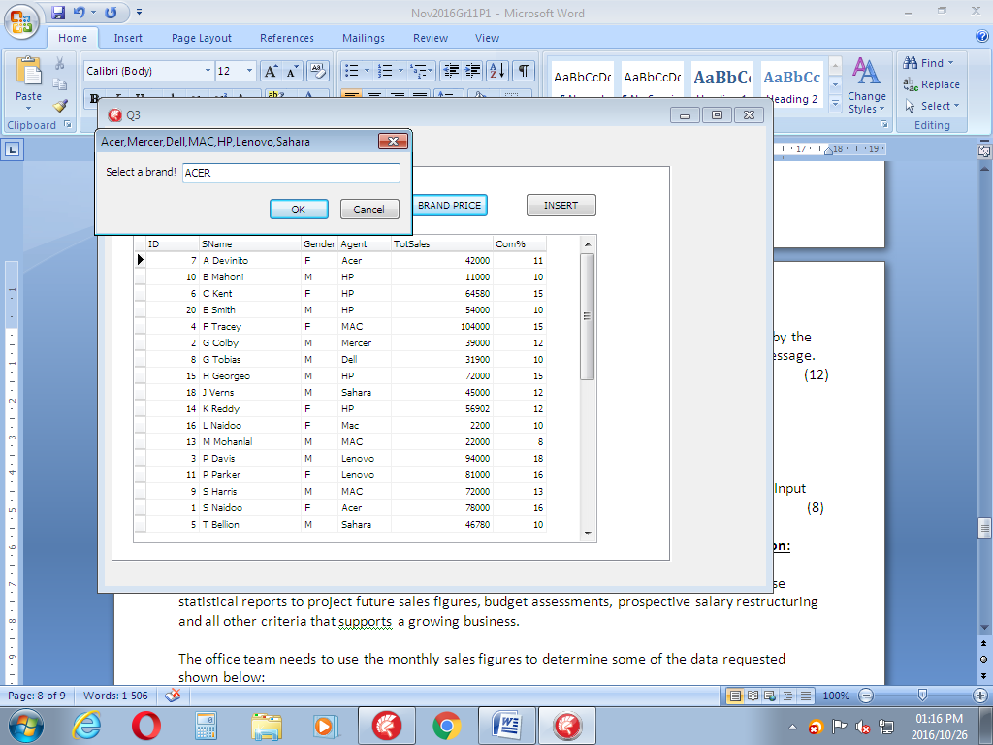

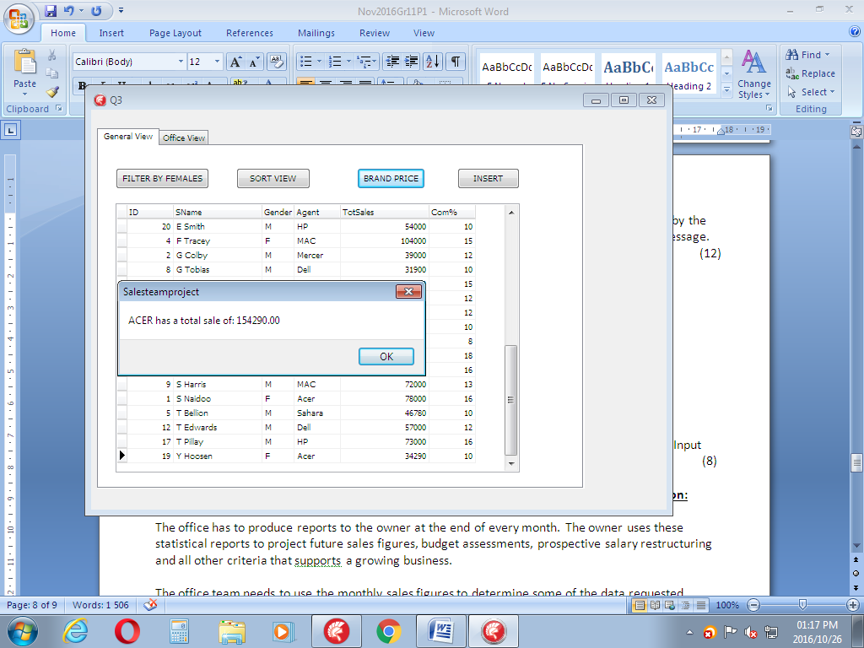

3.4. Code the **INSERT** button which allows a user to enter the different values using the Input

Box dialog. Once the details have been input, insert the data into the database table. (7)

**Write the necessary code for the View Stats button as described below in the Office View section:**

The office has to produce reports to the owner at the end of every month. The owner uses these statistical reports to project future sales figures, budget assessments, prospective salary restructuring and all other criteria that supports a growing business.

The office team needs to use the monthly sales figures to determine some of the data requested shown below:

1. **Highest sales** figure by a salesman.

2. **Lowest sales** figure by a salesman.

3. The **median** of sales figures.

4. A list of salesmen who fall below the median. These sales figures must be less than 80% of the

median.

Write the code using the database table to produce the data mentioned above in the format shown below:

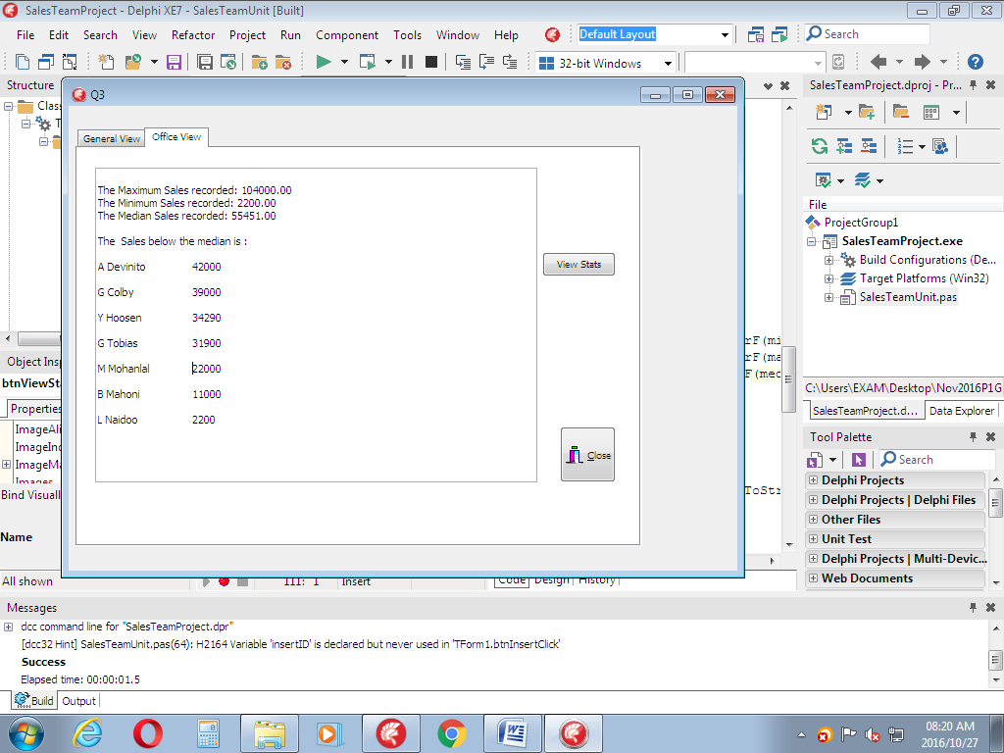

(22)

**[52]**

**GRAND TOTAL = 150**